Psalms
Series: The Story I Psalms, ESV I March 13, 2016

Songs are meant to be ________. Psalms are meant to be __________.

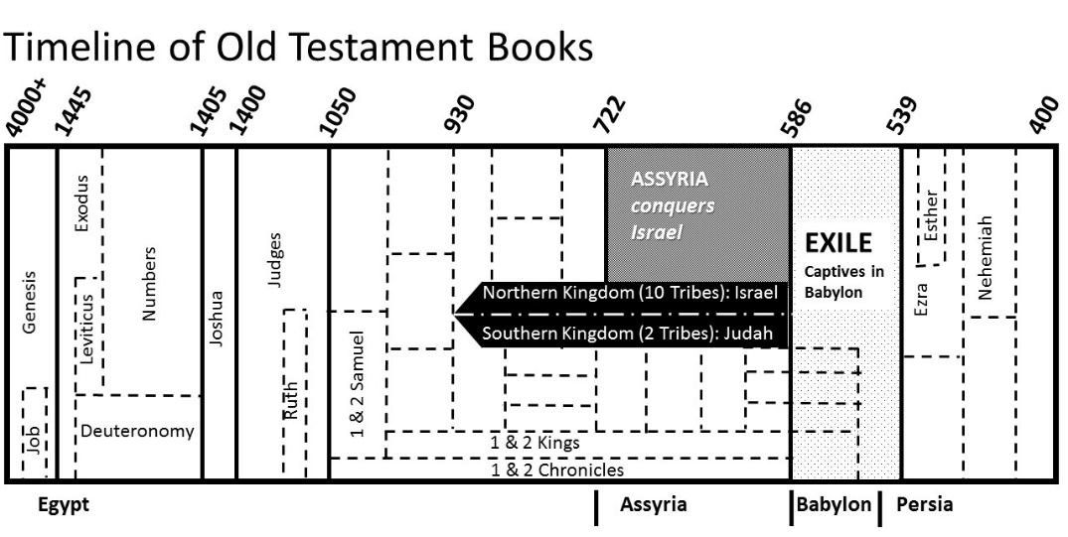

Authors…

Structure…

What God has done
Psalm 19:1-9 - What God has given

Psalm 2:6-8 - What God has done through _________________

Psalm 40:1-3 - What God has done personally and cosmically

Our Response: ______________________________________________________

What God will do
Psalm 16:8-10 - _______________ entered creation

Psalm 37:7-11 - Evil and injustice have __________________ the Law.

Psalm 110:1-2 - How will God fix this? Through _______________

Psalm 32:1-5 - Our response: ____________________________________

God, where are you now?
Psalm 44 - God, __________________________!

Psalm 137:1, 7-9 - _________________________ God for what they did!

Psalm 22 - The prayer of _________________________

Our Response: ____________________________________________________

